A-1:

Variables

* Invoice No
* Description
* Qty
* Unit Price
* Cust ID
* Country
* Cust Pr

The use of the Table 2 is to identify the variables and their data type. (meta data)

A-2:

**Variable Type**

Invoice No Nominal

Description Categorical

Qty Numerical

Unit Price Numerical

Cust ID Nominal

Country Categorical

Cust Pr Ordinal

A-3:

**Variable Type**

Invoice No Auxiliary

Description Independent

Qty Independent

Unit Price Independent

Cust ID Independent

Country Dependent

Cust Pr Dependent

A-4:

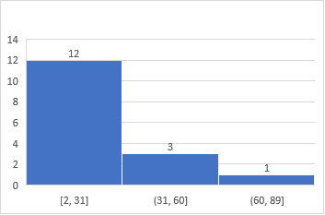

A-5:

A-6:

Not symmetrical. Skewed to the left.

A-7:

Sum = 297

* Mean = 56.02/sum(frequency)

= 56.02/16

= 3.50125

* Median = 2.325
* Mode = 2.55

A-8:

Variance = 10.0738383

Standard deviation = 3.17393105

A-9:

Sorted data = 0.42, 0.63, 1.25, 1.69, 1.79, 1.79, 1.85, 2.1, 2.55, 2.55, 2.55, 2.95, 5.95, 8.5, 8.5, 10.95

First half = 0.42, 0.63, 1.25, 1.69, 1.79, 1.79, 1.85, 2.1

Median = 1.74

Q1 = 1.74

Median of the Full data = 2.325

Q2 = 2.325

Second half = 2.55, 2.55, 2.55, 2.95, 5.95, 8.5, 8.5, 10.95

Median = 4.45

Q3 = 4.45

A-10:

